Docker assignment – 1

Create one repository in git add 3 branches. In each branch add index.html file.. create 3 containers from httpd image. Through the Jenkins job deploy index.html on these three container..

Step 1

Create one repository.. add three branches with index.html file

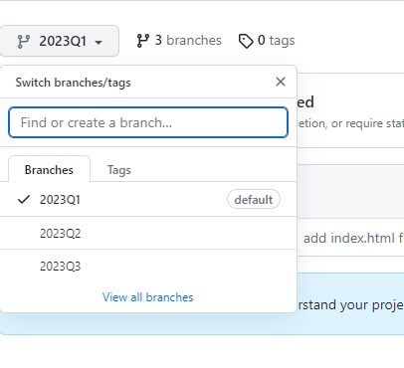

Step 2

Pull httpd image create three container from these httpd image..



Step 3

Create job through pipeline

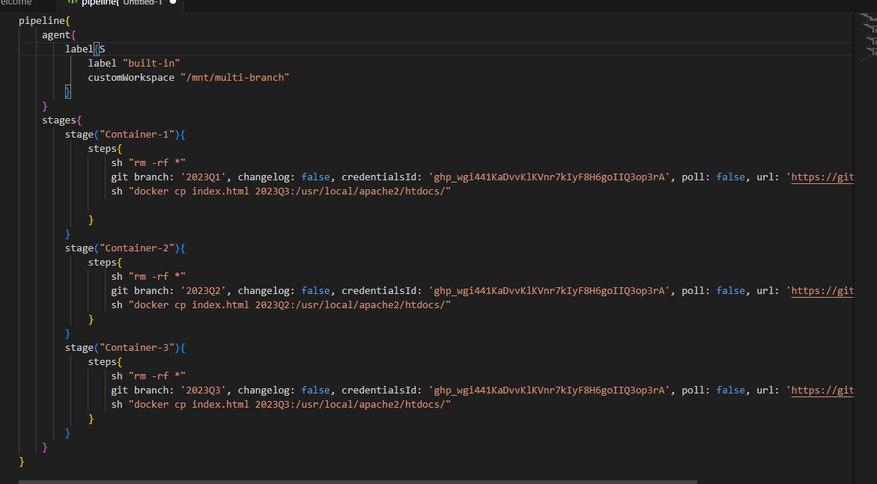

Step 4

Run this job

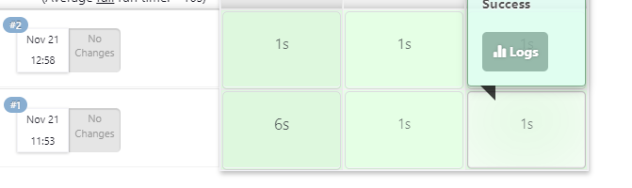

Step 4

Public IP hit on browser and see the output..